Toxic Comment Classification Challenge

By

Dillon Mantle

Submitted to

The University of Liverpool

MASTER-OF-SCIENCE-TITLE

CSCK507: Natural Language Processing and Understanding

Word Count: 538

25/11/2024

TABLE OF CONTENTS

Page

LIST OF TABLES 3

LIST OF FIGURES 4

Chapter 1. Introduction 5

Chapter 2. Model Development 6

2.1 Dataset Analysis 6

2.2 Model selection and Evaluation 9

2.3 Feature Extraction Experimentation 10

2.4 Kaggle submission 11

Chapter 3. Conclusions 12

LIST OF TABLES

Page
Table 1: Experimentation Results 10

LIST OF FIGURES

Page

Figure 1: Most Frequenct Words for "Identity Hate" class 6
Figure 2: Most Frequenct Words for "Insult" class 7
Figure 3: Most Frequenct Words for "Obscene" class 7
Figure 4: Most Frequenct Words for "Severe Toxic" class 8
Figure 5: Most Frequenct Words for "Threat" class 8
Figure 6: Most Frequenct Words for "Toxic" class 9
Figure 7: Kaggle Submissions 11

Introduction
Online hate speech and fake news are pervasive issues on social media. Despite efforts to combat them, these problems persist, negatively impacting individuals and society (Walther, J. B., 2022). Developing effective methods for detecting and mitigating these issues is essential for protecting users and fostering a healthy online environment (Council of Europe, 2023).

Leveraging text preprocessing, feature engineering, and advanced classification algorithms, I developed a model to identify toxic content. This report analyzes the dataset, feature extraction, and model performance.

Model Development
The solution has been built using Python, and a combination of the NLTK and SciKit learn python packages.
  - Dataset Analysis
The dataset contains 159,571 comments, each labeled with six types of toxicity. The data was preprocessed to clean up the text, including removing stop words and stemming. While lemmatization was attempted, it didn't improve the results. Translating all comments into a consistent language could potentially enhance performance.
Figure 1: Most Frequenct Words for "Identity Hate"
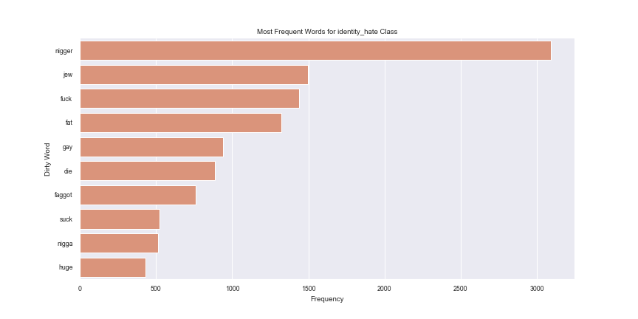
Figure 2: Most Frequenct Words for "Insult"
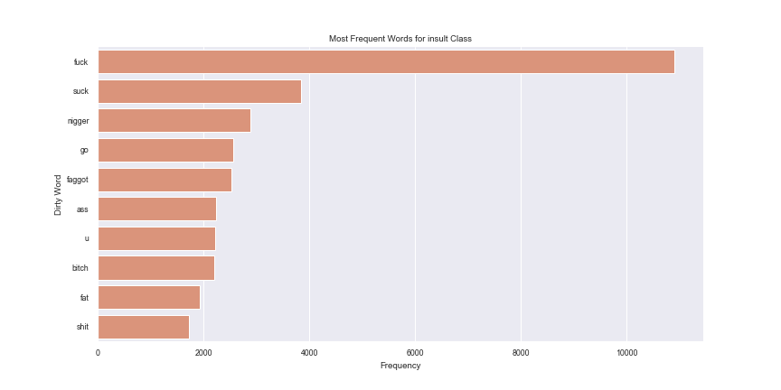
Figure 3: Most Frequenct Words for "Obscene"
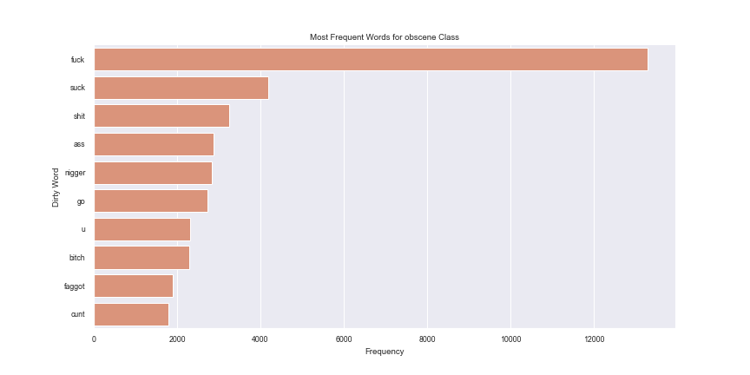
Figure 4: Most Frequenct Words for "Severe Toxic”
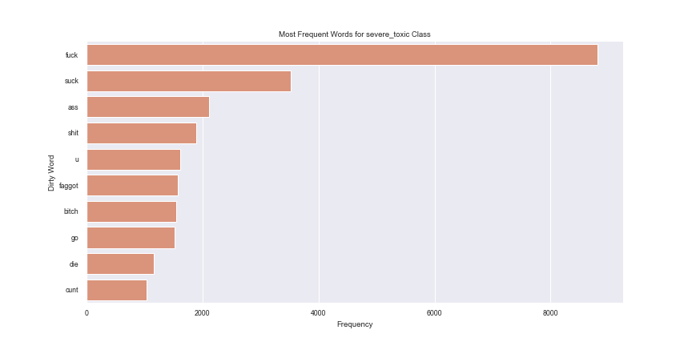
Figure 5: Most Frequenct Words for "Threat"
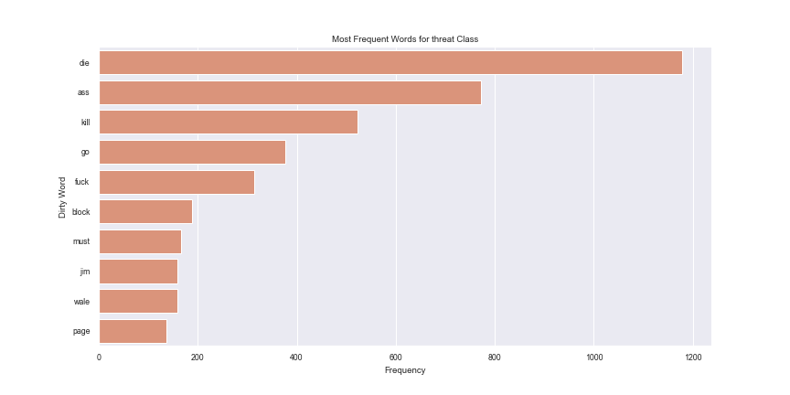
Figure 6: Most Frequenct Words for "Toxic"
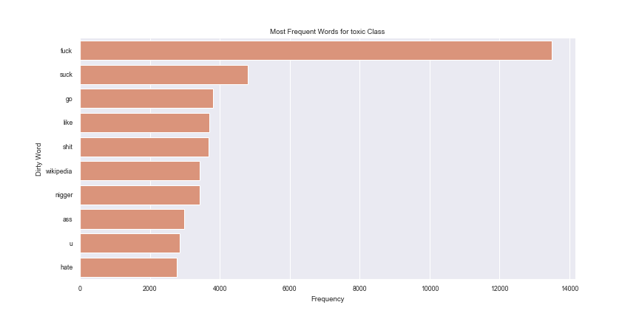
  - Model selection and Evaluation

Three classification models were selected for evaluation: Logistic Regression, Random Forest, and Decision Tree. Logistic Regression is a straightforward model that provides probabilities for binary classification and serves as a benchmark for more complex models. Random Forest, an ensemble method, combines multiple decision trees to reduce overfitting and improve generalization, handling both numerical and categorical data. Decision Trees, while simple and intuitive, are prone to overfitting, particularly with deep trees.
  - Feature Extraction Experimentation
To extract features from the textual data, three methods were evaluated leveraging the following performance metrics:
- AUC (Area Under the ROC Curve) measures the model's ability to distinguish between positive and negative classes. A higher AUC indicates better performance (Google, 2024).
- Log-Loss quantifies the discrepancy between the predicted probability and the actual class label. Lower log-loss values suggest more accurate predictions (Google, 2024).
Table 1: Experimentation Results
Model | Metric | Tfidf  Vectoriser | Count  Vectoriser | Hashing  Vectoriser
Logistic  Regression | ROC AUC | 0.9802478 | 0.8017343 | 0.9629719
Logistic  Regression | Log Loss | 0.0520927 | 0.1809500 | 0.0663411
Random  Forrest | ROC AUC | 0.9628736 | 0.9618651 | 0.9225949
Random  Forrest | Log Loss | 0.0670111 | 0.0702430 | 0.0919392
Decision Tree | ROC AUC | 0.6832263 | 0.7706536 | 0.5493276
Decision Tree | Log Loss | 0.5904623 | 0.4538123 | 1.0651960

For the given dataset and task, TF-IDF Vectorizer is the most effective feature extraction technique, especially when used with Logistic Regression. TF-IDF's ability to weight words based on their importance, combined with Logistic Regression's simplicity and interpretability, makes it a powerful combination for hate speech detection (GeeksForGeeks, 2023).

  - Kaggle submission
The highest Kaggle score obtained was 0.93664

Figure 7: Kaggle Submissions
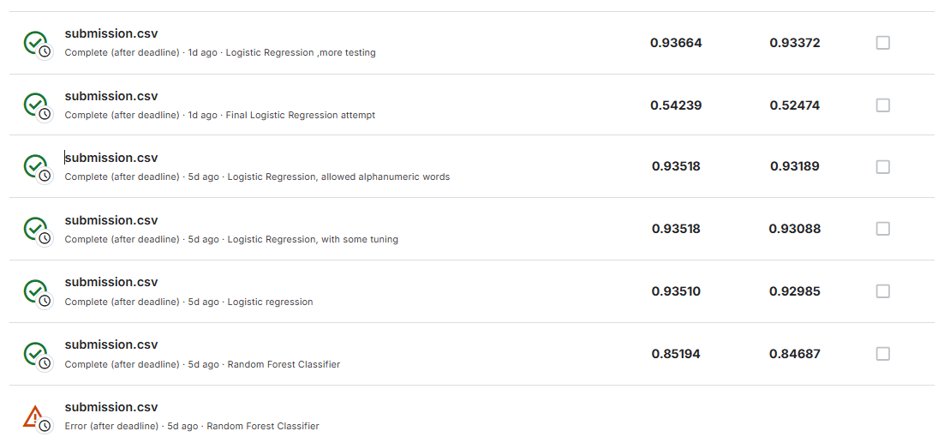

Conclusions
This report investigated the development of a model to identify toxic content on social media. The model utilized text preprocessing, feature engineering, and advanced classification algorithms to mitigate the negative impact of online hate speech and fake news. The analysis highlighted the prevalence of various toxic categories within the dataset. The TF-IDF Vectorizer, when combined with Logistic Regression, proved to be the most effective feature extraction technique. While the model achieved promising results, further improvements, such as incorporating language translation, can enhance its performance.
REFERENCES
Walther, J. B. (2022). Social media and online hate. Current Opinion in Psychology, 45, 101298. doi:10.1016/j.copsyc.2021.12.010
Council of Europe, 2023. Study on preventing and combating hate speech in times of crisis. Available at: https://rm.coe.int/-study-on-preventing-and-combating-hate-speech-in-times-of-crisis/1680ad393b (Accessed 28 October 2024)
Google, 2024. Classification: ROC and AUC. Available at: https://developers.google.com/machine-learning/crash-course/classification/roc-and-auc (Accessed 23 November 2024)
Google, 2024. Logistic regression: Loss and regularization. Available at: https://developers.google.com/machine-learning/crash-course/logistic-regression/loss-regularization (Accessed 23 November 2024)
GeeksForGeeks, 2023. Understanding TF-IDF (Term Frequency-Inverse Document Frequency). Available at: https://www.geeksforgeeks.org/understanding-tf-idf-term-frequency-inverse-document-frequency/ (Accessed 23 November 2024)

